Preparing Cheques for Payment Documents

S.NO. : 03- FI-Bank- 01

TRANSACTION CODE : FCH5

ACCESS PATH :SAP Easy Access Accounting Financial
Accounting Banks Environment
Check balance Create Manual Checks

We get “ Create Check Information” screen as under;
Required fields

Payment Document Number Enter the payment Document Number
Paying Company Code Default (Grow)
Fiscal Year Default (eg: 2001)
House bank To be entered (eg: Cbi)
Account ID To enter the A/c Number maintained in the bank
Check Number next free number of the cheque to be entered

Incorporating the above we get the “ Create Check Information” screen as under

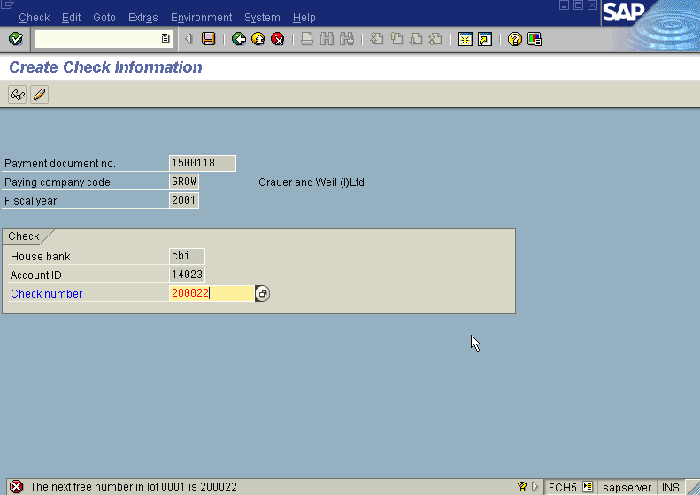

Press Enter icon

The system displays “ Create Check Information” screen as under

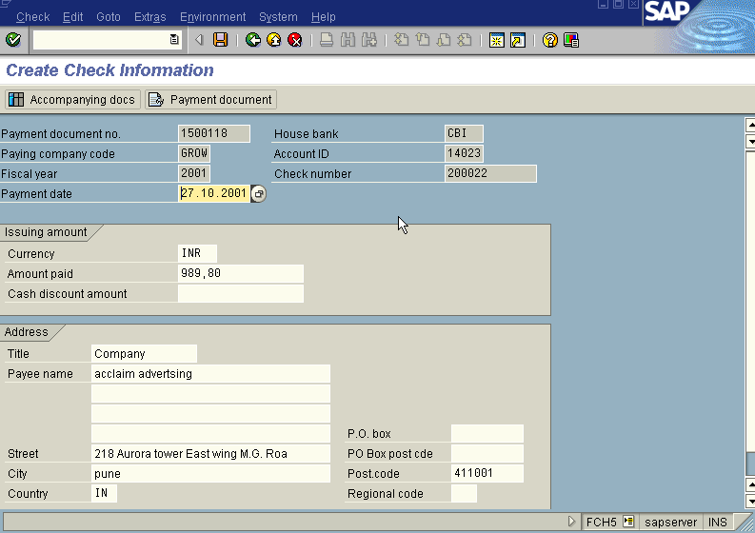

Verify all the details viz; amount, payee, etc. And make necessary changes
if required before saving the document.

Press save icon

We get the following message as under

End of the process.

